Odyssey Rochester Review: Draft 4
Zvi Mowshowitz
Thursday, January 24, 2002
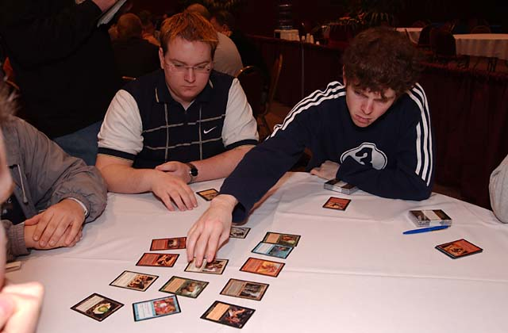
Drafting is about signals.
My final draft at Pro Tour-San Diego had a lot of top players in it, including Kai Budde, Ryan Fuller and Kamiel Cornelissen. The first section of the table seemed normal. A blue card went first, then Scott Richards took the first card for what it quickly became clear was a red-green deck. Kamiel went white, and just like in draft three I saw my chance. If nothing white was taken between Kamiel in seat 3 and me in seat 7, I was definitely going white along with him. This time, however, things got pretty murky. Ryan took a black card behind Kamiel's white card, which is problematic. What are Ryan and Kamiel's plans here? Kamiel is behind Scott Richards, and if as expected Scott goes red-green then the only way Kamiel doesn't take black himself is to go blue-white.
What is Ryan's second color going to be? It could certainly be green, if Ryan is willing to draft that color combination. It probably won't be white or blue, because that means he'll be fighting Kamiel. Therefore the most likely intent is to go black-red. That puts Kai in a good seat to draft green, but a lousy one to draft red from. The problem was that there were no worthwhile green cards left in the pack, and Kai chose to take Ashen Firebeast. Scott McCord then took a green card, and I was content to fill in the other half of the white equation. Once again my announcement of white kept the player to my left out of my hair, especially since he was squeezed between two blue mages. I signaled blue on the wheel, and my position seemed relatively secure.
For the rest of the draft, I stayed in blue. The next few packs gave me virtually nothing worthwhile for my deck, but I stuck to my guns. The only question that did come up was whether I should go into black instead of white, and that happened because my good friend Kamiel's deck was getting wrecked to the extent that he felt he could no longer sustain the force, and Reinhard Blech was having such a hard time with black-blue in seat one he had to venture into a degree of white, even though he had almost no practice with it. That combined with the mix-up in the middle of the table to create a very confusing situation.
The first important decision was Scott McCord's, as he chose to play red-green right from the start. After the draft, Kai couldn't figure out what Scott was thinking, since Kai was 'obviously green'. On the flip side, Scott said that by the time Kai made it clear he was drafting green, it was too late for Scott to do anything about it. Someone dropped the ball here, but who? Kai was behind Ryan Fuller, and Ryan started with a black card behind a white card. As I said above, that might indicate green but probably indicates red. Kai took Ashen Firebeast.

Someone dropped the ball here, but who?
To the casual observer, this looks like a perfectly normal friendly pick, but looking at the picks carefully it's not all that friendly. Kai is trying to preempt Ryan out of red and into some other color, with the most likely choice being green. Regardless of whatever else happens, it certainly seems very likely that one of the two Pros will end up playing green. With Kamiel Cornelissen behind them drafting white, for both of them to pass up green would leave a very large hole in the draft and leave McCord in an amazing position. It is rare to see three players in a row without green in their decks, since the person in the middle of the gap will see an opening to go into green himself. Seeing two players next to each other is much more common, but it still requires that the player without a green mage to his right have a superior alternative to draft instead of green. Here, Kamiel and Ryan were going to be playing four different colors. If Ryan doesn't draft green, then neither of them will, which means that it's very likely that task will fall to Kai. That means that for Scott to be in a good green position, he has to hope that Ryan goes into green before Kai does. It's important not to get greedy when trying to manipulate a Rochester table, because if a position is too good, an adjacent player will step in to reap the benefits. The goal is to create a stable table, where no one has an incentive to rock the boat.
So in Scott's position, he has two choices. If he passes up the chance to go green, then we're looking at a table that may have only three green mages. I will probably go green in his place, Scott Richards will be green, and either Kai or Ryan will be green. There's only one way that there are still four green mages, which is that both Kai and Ryan go green, and that's certainly a possibility. In fact that's probably what would have happened, because I would have seen that it could happen and passed up green myself and taken white. That shifts the last green seat to position 8, and sets me up for the white force. The only issue there is I don't think Scott knew I would be likely to do that, and most players wouldn't either know that I would do it or do it themselves.

I wasn't about to hand [Ryan] the table on a silver platter.
The problem is that most tables are either 'even' or 'odd,' in the sense that either there are green players in the odd seats and blue players in the even seats or vise versa. Any break in that chain creates an imbalance. At any rate, Scott felt that he had to go green early on, and he established that he was green before Kai had to make his choice. In his mind, the choice was easy. The two players to his right were not green, therefore he was green. Ryan had received a decent chance to signal green and passed it up, so the coast was clear once Kai declared. This left Scott to fight with Kai over green, but he'd already committed. I was deep into the blue side of things and wasn't coming back, so he just had to ride out the situation.
When I had to choose between white and black, it was a matter of personal preference, but white was definitely the safer choice in terms of the number of drafters of each color at the table. I had been in a clear white position, but like Kamiel, I didn't have any white cards, and the white situation at the table was beginning to shift out from under me. Kamiel had started taking black cards, and Ryan had taken a white card or two. Ryan's mistake was to read too much into Kai's first pick. Kai never took a second important red card, but Ryan still stayed away from red. He focused in on black for a while, eventually slipping into white when Kamiel started moving away from white into black. There was no way out of black for Ryan, so Kamiel's decision ensured they would fight over it, but there were still only three black players at the table so it should have been all right. The only white card Kamiel ended up playing was an Iridescent Angel. If I had abandoned white, Ryan would have been alone as the only heavy white drafter, and I wasn't about to hand him the table on a silver platter.
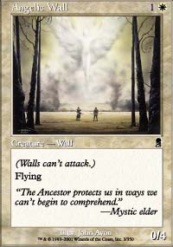
For the first time, issues of counterdrafting and retaliation came up at this table. Scott McCord took away two cards from me, an Angelic Wall and an Embolden, and at the time I was struggling on card count. I also just really like both cards in the white-blue archetype. Needless to say, I wasn't happy. I know Scott pretty well, and I knew he had taken those cards because they're strong against red-green, so I wasn't about to go on tilt or anything, but I was done playing nice on purpose. The next few packs were really frustrating. First there was a Rabid Elephant and a Springing Tiger with nothing I wanted for my deck. If I was drafting just for my deck, I probably actually take one of them, which one depending on my curve and how good I am at getting threshold at the time (but leaning towards the Elephant on instinct) in case my deck gets into trouble and I have to splash or I get into a matchup where I want to be splashing on purpose. In a practice draft right before the Tour, I had a white-blue deck that was short enough on offense that I chose to splash for a Rabid Elephant. But I had to look at what would happen to the pack. If I take one of the two green cards, Scott takes the other, and all it does is destroy Kai's wheel! For three straight packs, this shield kept Scott's picks safe, as I sadly took poor cards knowing that venturing out of my colors would do nothing but harm a teammate. Later on, I saw the opportunity to hate away cards at a distance, and I see no need to be nice to people more than two seats away from me. Drafting is a zero sum game, and there's no reason to help everyone's deck just to be nice. In addition, there are some players you don't want to be nice to for whatever reason.
With the issues surrounding the table out of the way, the last question is the proper way to draft white-blue. Although I drafted white-blue in the third pod, I never got to talk about it because that draft was so crazy that I was neither building a standard deck or building my deck to deal with standard opponents. Here the opposition was fairly normal, although I had multiple Iridescent Angels to worry about. This time I had a chance to draft normally. Many players view white-blue as a color combination that has to splash a touch of red or black for removal cards like Ghastly Demise or Firebolt. To justify that, they point to cards like Chainflinger and Nantuko Disciple, and claim that they can single handedly annihilate you. They're often right. There are plenty of games where I've played Nantuko Disciple and used it to run right over a white-blue deck's defenses. There are plenty of games I've wiped out half their board or simply killed them with a Chainflinger. There are plenty of games I've been on the receiving end of both.
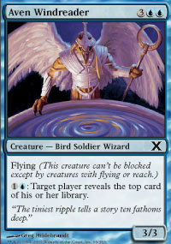
What many players don't realize is that this vulnerability comes from trying to play white-blue as a defensive deck when it should be played as an offensive one. As with all the strategies in Odyssey, you want to do one thing and focus on doing it well. White-blue's goal should be to attack with massive quantities of flyers. When I'm asked what the goals should be when drafting white-blue, I say that nothing is more important than flyers. There are individual cards you'll take over any given flyer, but it's the key piece of the puzzle to fly over for a bunch of damage. A good rule of thumb is that if you can take the flyer without wincing, you should take it unless you're well ahead of the game in drafting them. Anything less than about five is trouble and, within reason, the more the merrier.
Once you've got the tools to fly over for the win, the goal is to defend the ground. Make the assumption from the moment that the deck is clearly blue-white that you will not attack on the ground with anything but a lucky early Patrol Hound or sometimes with a Dreamwinder. The best defensive creatures don't take up valuable mana trying to generate the ability to attack. That's why I like creatures like Angelic Wall, Luminous Guardian or Blessed Orator. The Pilgrims aren't particularly strong cards, but they're not all that weak either, and they're often very good at defending. They need to be respected and drafted more than they are, especially the Pilgrim of Justice. If nothing else, they're always welcome in the sideboard. Dreamwinder is the one exception, and that's because it has text on it saying that it sometimes can't attack. That makes it cheap enough for its cost that when it's allowed to attack, that attack is often worthwhile, and paying for the four power doesn't break the bank. Kirtar's Desire goes from a borderline card everywhere else to wonderful here, taking out anyone who doesn't fly for one mana. Technically it can block, but it never will.
Just as the deck should concentrate on flyers, it should concentrate on creatures in general. When you're paying the extra mana for flyers, it's easy to fall behind. Not only must the deck keep an eye on its curve, it wants to spend the first few turns tapping out for creatures. Once the board starts to get more complicated, it's time for the kind of tricks that let the flyers do their 20 damage before they can do 20 on the ground. It's horrible when you get into a situation where you have to hold back your mana or face a devastating attack. Second Thoughts is actually pretty bad if there's no attack in the air. By attacking them for four, you force them to attack on the ground rather than play around the Second Thoughts and build up your forces. Anything that can keep you up on tempo is welcome, such as Syncopate or Aether Burst. Generally I like having one Embolden a lot, but in good versions the second one stays in the sideboard for decks where it's needed.
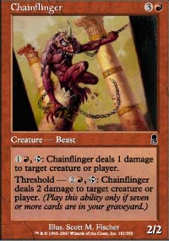
When you're going for the throat, you don't have to stop everything. That makes cards that stop you from stopping everything a lot less problematic. A Nantuko Disciple will eventually push through almost any defense that doesn't involve a Hallowed Healer, and the same is true of a Rabid Elephant if it isn't removed. A Chainflinger will slowly get through anyway. Chainflinger is a special case, and it helps a lot to just avoid drafting one toughness creatures if they're not needed. By the time the Chainflinger gets going with threshold, your flyers should be hard at work. If the flyers don't come and the deck ends up going on the defensive for real, a splash becomes a much better idea. At some tables, it may even be necessary. Watch the cards that give you trouble and react accordingly.
One final note is on the card Psionic Gift. A lot of people really like it in white-blue, some going so far as making it a key component of the deck. I agree that the Gift is very good in white-blue, and it's even more important than usual in a more defensive version. The hype is still a little out of control. Gift is a nice card to have, but it's far from required and I don't feel bad about not having one. If I have multiples, generally I'll only start one of them and sideboard the rest if they seem good against a particular opponent. That's where they really shine, because sometimes you'll get an opponent whose deck simply collapses in the wake of a Gift. That said, I strongly disagree with taking it over cards like Aven Fisher until the outlines of the deck are clear. Once the other bases are taken care of getting additional options gets higher priority, but Psionic Gift is not one of those bases.

